WEEK 4(TASK 9,10):

Aim:To compute the block sum for each element of a matrix such that every element (i, j) in the result matrix contains the sum of all elements within a distance K from (i, j) using an efficient prefix sum approach.

Algorithm:
- Read input matrix mat and integer K.
- Create a prefix sum matrix prefix of size (m + 1) × (n + 1) initialized to 0.
- Build the prefix sum matrix
For each cell (i, j):
  - Add the current element.
  - Add the sum from the top.
  - Add the sum from the left.
  - Subtract the overlapping top-left value.
- Initialize the result matrix result of size m × n.
- For each cell (i, j) in the matrix:
  - Determine the block boundaries:
    - r1 = max(0, i − K)
    - c1 = max(0, j − K)
    - r2 = min(m − 1, i + K)
    - c2 = min(n − 1, j + K)
  - Compute the block sum using the prefix sum formula:
  - blockSum =
  - prefix[r2 + 1][c2 + 1]
  - − prefix[r1][c2 + 1]
  - − prefix[r2 + 1][c1]
  - + prefix[r1][c1]
- Store the computed block sum in result[i][j].
- Return the result matrix.
Program:
class Solution {
public int[][] matrixBlockSum(int[][] mat, int k) {
int m = mat.length, n = mat[0].length;

int[][] prefix = new int[m + 1][n + 1];
for (int i = 1; i <= m; i++) {
for (int j = 1; j <= n; j++) {
prefix[i][j] = mat[i - 1][j - 1]
+ prefix[i - 1][j]
+ prefix[i][j - 1]
- prefix[i - 1][j - 1];
}
}
int[][] result = new int[m][n];
for (int i = 0; i < m; i++) {
for (int j = 0; j < n; j++) {
int r1 = Math.max(0, i - k);
int c1 = Math.max(0, j - k);
int r2 = Math.min(m - 1, i + k);
int c2 = Math.min(n - 1, j + k);
result[i][j] = prefix[r2 + 1][c2 + 1]
- prefix[r1][c2 + 1]
- prefix[r2 + 1][c1]
+ prefix[r1][c1];
}
}
return result;
}
}
Output:
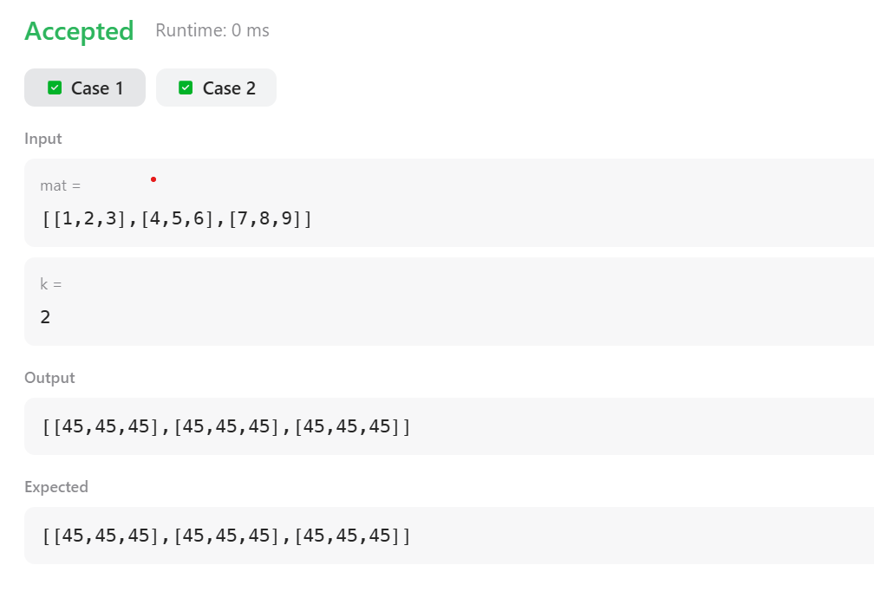

Result:
Thus the implementation of the matrix block sum was executed successfully and out put was verified successfully.

AIM:
To rotate a given square matrix by 90 degrees clockwise in place using an efficient algorithm without using extra space.

ALGORITHM :
- Transpose the matrix
  - Convert rows into columns.
  - Swap matrix[i][j] with matrix[j][i] for all i < j.
- Reverse each row
  - For every row, reverse the elements from left to right.
- The matrix is now rotated 90° clockwise.
PROGRAM:
class Solution {
public void rotate(int[][] matrix) {
int n = matrix.length;
for (int i = 0; i < n; i++) {
for (int j = i + 1; j < n; j++) {
int temp = matrix[i][j];
matrix[i][j] = matrix[j][i];
matrix[j][i] = temp;
}
}
for (int i = 0; i < n; i++) {
int left = 0, right = n - 1;
while (left < right) {
int temp = matrix[i][left];
matrix[i][left] = matrix[i][right];
matrix[i][right] = temp;
left++;
right--;
}
}
}
}
OUTPUT:
1 2 3
4 5 6
7 8 9

7 4 1
8 5 2
9 6 3

Result:
Thus the implementation of the matrix rotation algorithm was executed successfully and out put was verified successfully

